Alcoholics Anonymous
BIG BOOK WORKSHOP
“Joe and Charlie”
This is an ONGOING 2022-20023 group read along and discussion workshop.
Zoom only EVERY TUESDAY AT 6pm
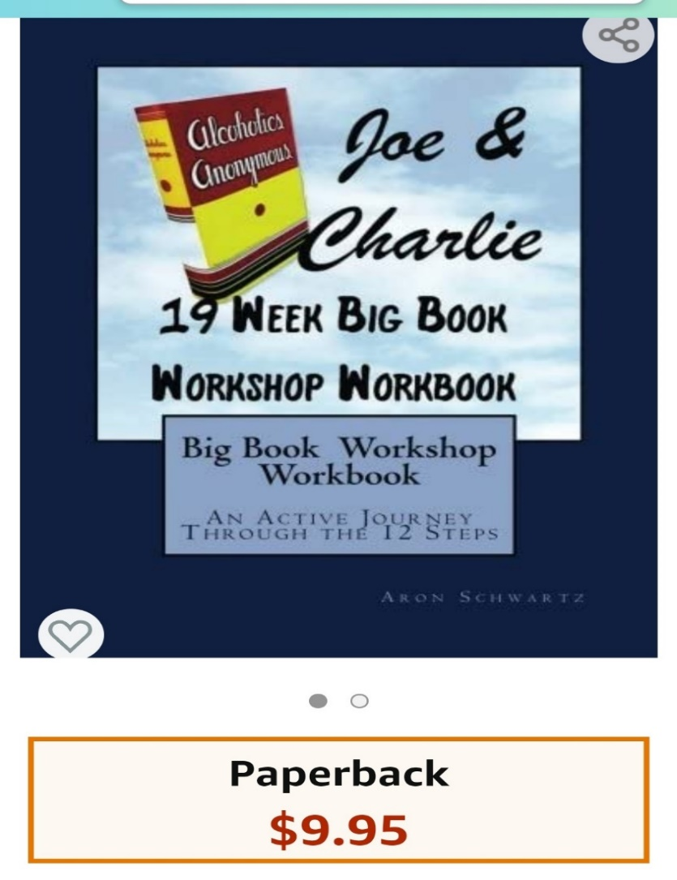
ORDER THE workbook on Amazon or get one from Angie Tapley
(760) 937-5772
tapleyhome@schat.net
Contact Angie for questions.

ZOOM Login codes,
Meeting ID -96154213759
Passcode- 200132

